Rapid RAG for your existing Applications : Modernize Apps built using SQL in Minutes

Prerequisites
Before deploying the template, ensure you have the following:
- Azure Trial Subscription or any Azure Subscription with Credits
- Permissions to create resources in the selected resource group
- Install VS Code . Create python environment Python environments in VS Code, with python version atleast 3.12.10
- Sufficient quota for Azure OpenAI resources .
We will be deploying 2 models: gpt-4.1 & text-embedding-ada-002/ text-embedding-3-small

Getting Started:
Welcome! 🎉 This repository contains two solution accelerators.
Today we will use two Streamlit applications that demonstrate how to build Retrieval-Augmented Generation (RAG) solutions using Azure SQL Database's native vector capabilities and Azure OpenAI. The apps are designed for:
- Product Review Search: Upload and semantically search product reviews using CSV data. - Structured Data RAG
- Resume Matching: Upload and semantically match resumes using PDF documents. – Unstructured Data RAG
Both apps allow users to generate embeddings, store/query them in Azure SQL DB, and perform LLM-powered Q&A for intelligent retrieval and recommendations.

Products & Services Used
- Azure SQL Database (VECTOR data type)
- Azure OpenAI Service (Models used gpt-4.1 & text-embedding-ada-002)
- Azure Document Intelligence (For PDF Resume parsing)
- Streamlit App for Demo
- Python (pandas, pyodbc, tiktoken, etc.)

🚀 Step 1: One-Click Deployment Accelerator
Purpose: Automatically deploy the entire Azure SQL + OpenAI setup for a Retrieval-Augmented Generation (RAG) application using an ARM template.
Highlights:
- One-click deployment via Azure Resource Manager (ARM)
- Sets up Azure SQL Database, OpenAI integration, and supporting resources
- Reduces manual configuration to just click and go
- Completes setup in under 10 minutes
Note: If the below resources are already in your environment, you can skip the setup steps and proceed to the next section 🌐 Step 2: Web-Based Demo for Vector Search
✅ Azure OpenAI Models:
- gpt-4.1 for chat/completion tasks
- text-embedding-3-small or text-embedding-ada-002 for generating embeddings
- An accessible Azure SQL Database
- Azure Document Intelligence
We can perform the demo with the Free tier for Azure SQL and Document Intelligence

Setup Instructions:
- Navigate to the folder Step1-OneClick-Deployment

- Since we will be doing both demos : RAG on Structured & Unstructured Data.
We will deploy the below option:
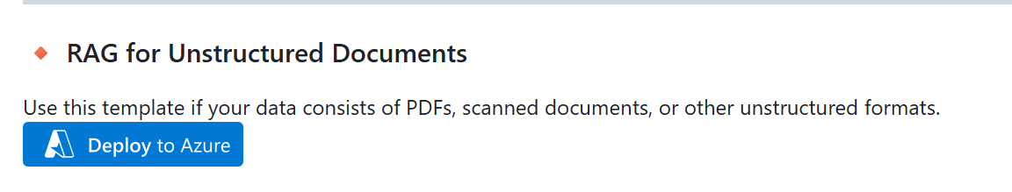
You can also click this link directly
This will open the Azure Portal. Fill the required details into the template like:
- Resource Group Name.
- Customize the server (or resource) name by appending your name or initials to the default values.
- Add the Admin and the Password for SQL Server (This creates a Free SQL Server DB)
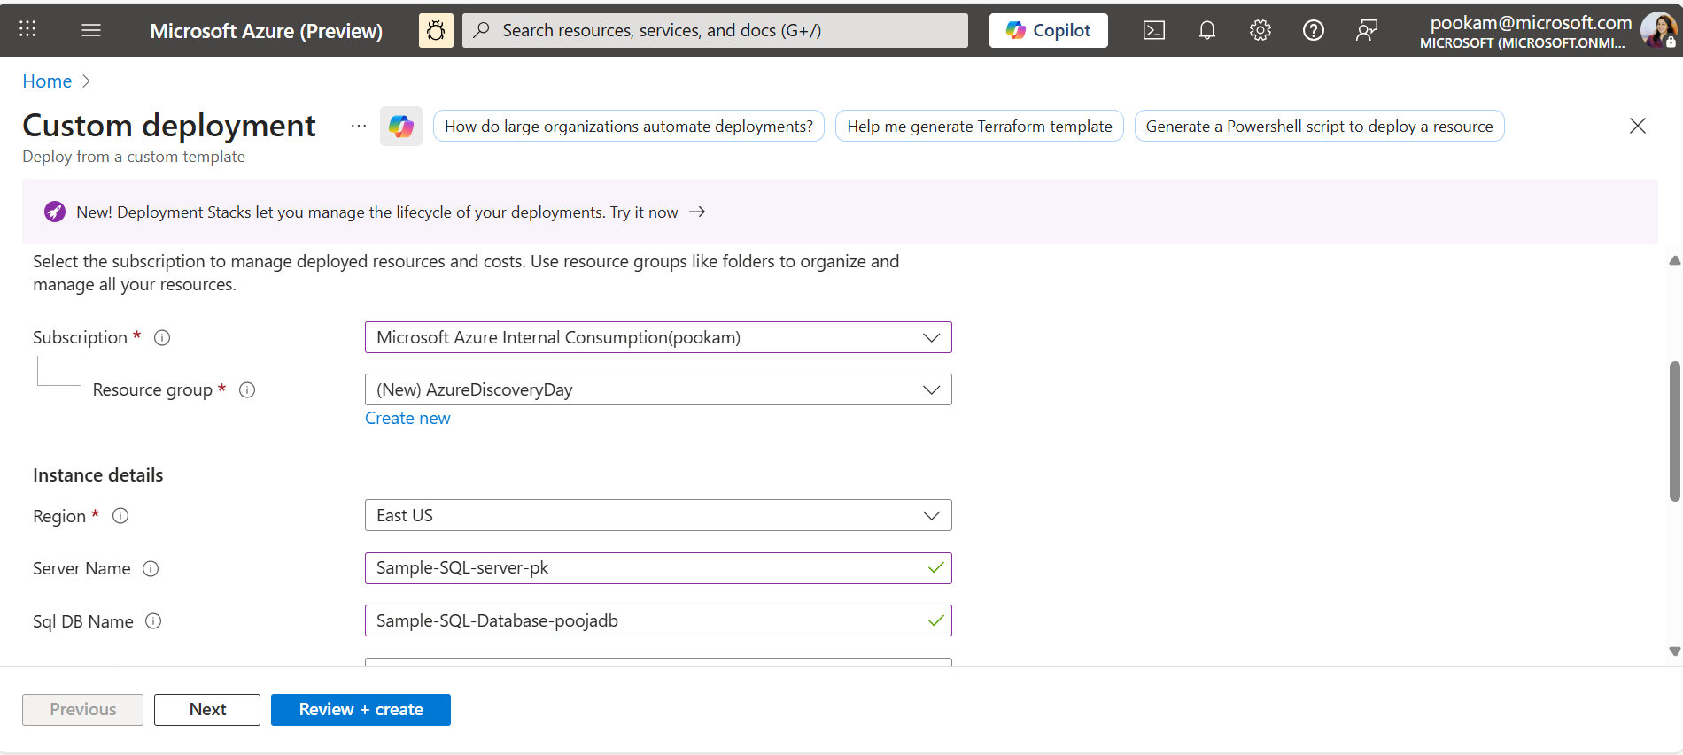
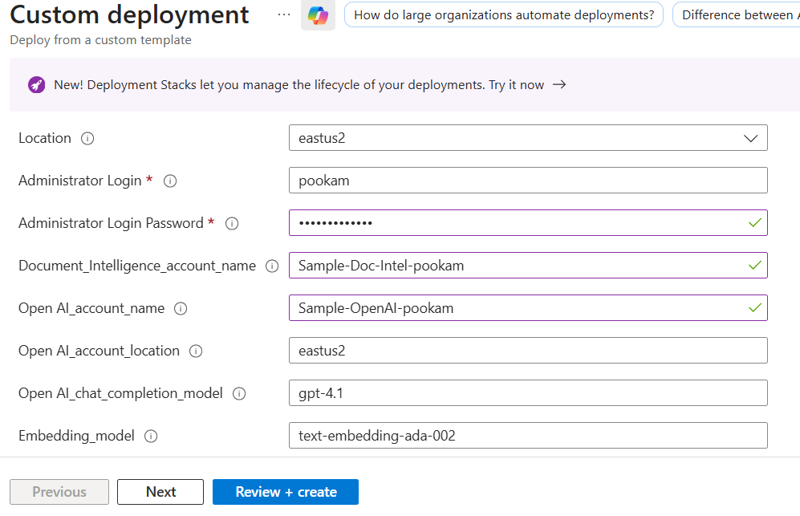
- Verify all details.
- Click Review + Create, then Create to deploy the server.
- Once deployed, your backend RAG infrastructure is ready to use.
You can check your Resource Group to see if the 4 resources have been created
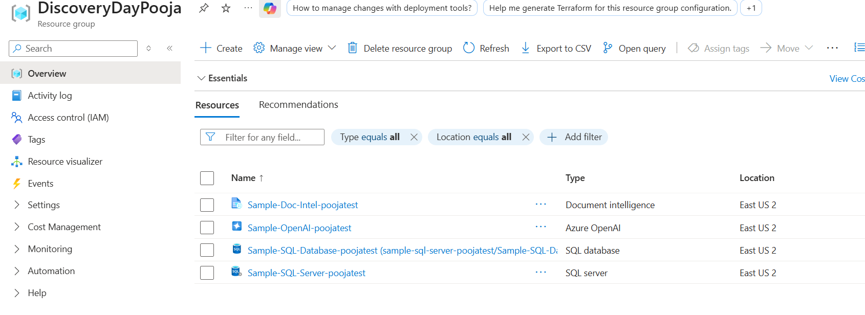

- Setup Firewall Configuration:
  - Configure the firewall settings for the SQL server separately to allow access from your client IP addresses.
  - Go to the deployed SQL Database in the Azure Portal.
  - Click on Set Server Firewall - Add your client IP and click Save.
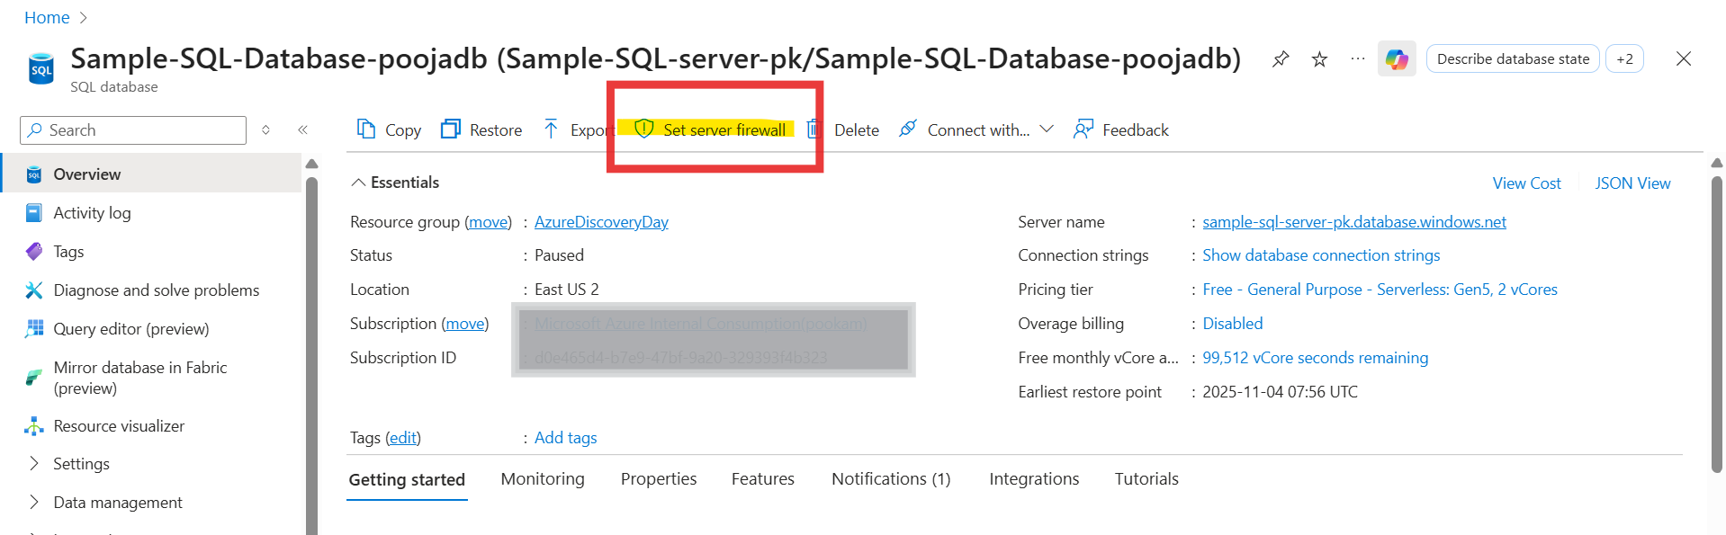
Let’s now move on to creating a Web UI:
Demo 1: RAG for Structured Data:

🌐 Step 2: Web-Based Demo for Vector Search
Purpose: Launch a Streamlit-based web UI that showcases Azure SQL’s native vector search capabilities.
Highlights:
- Visual demo for semantic search scenarios (e.g., product search, resume matching)
- No coding required to explore and validate vector search
- Helps users understand and interact with vector search features in Azure SQL
Setup Instructions:
- Open Visual Studio Code
Launch VS Code on your machine.
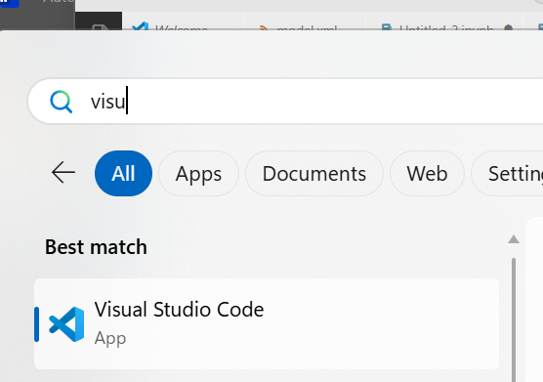
- Open the Command Palette
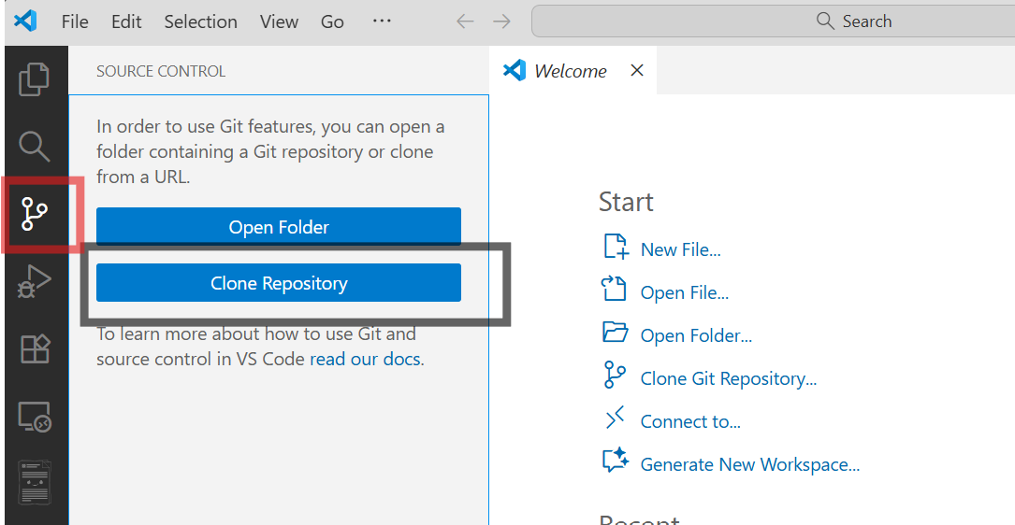
- Click Clone Repository & Enter Repository URL
https://github.com/Kushagra-2000/sql-vector-search-demo.git
(You can use this repo if you do not want to Clone the Entire Azure SQL AI Samples Repository)
Press Enter
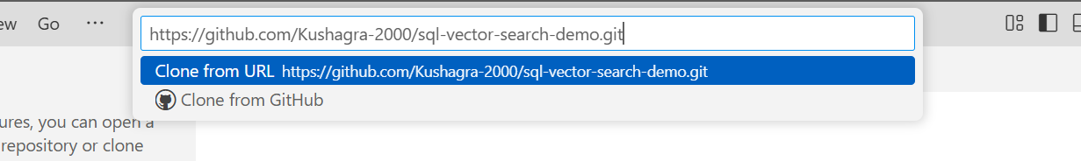
- Choose a Local Folder : Select the folder where you want to store the cloned project.
- After cloning, VS Code will prompt you to Open the repository. Click Open.
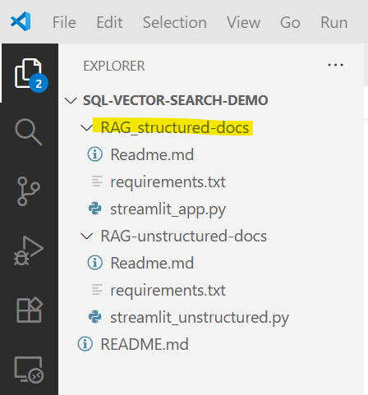
- Navigate to corresponding repository depending upon structured or unstructured dataset.
View Terminal
cd RAG_structured-docs
- Install Requirements:
pip install -r requirements.txt

- Navigate to the cloned repository destination and then run the below command to start the app on localhost:8501
streamlit run streamlit_app.py --server.maxUploadSize 500

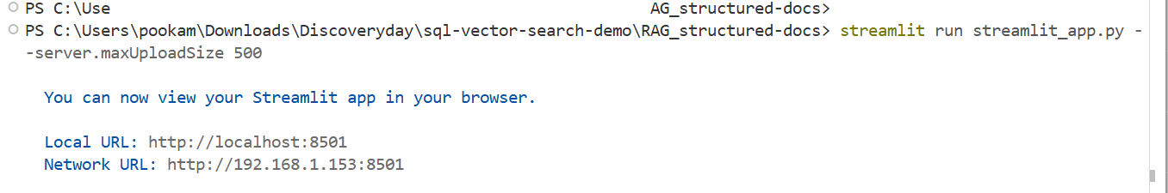
- This will open the browser with the Streamlit App
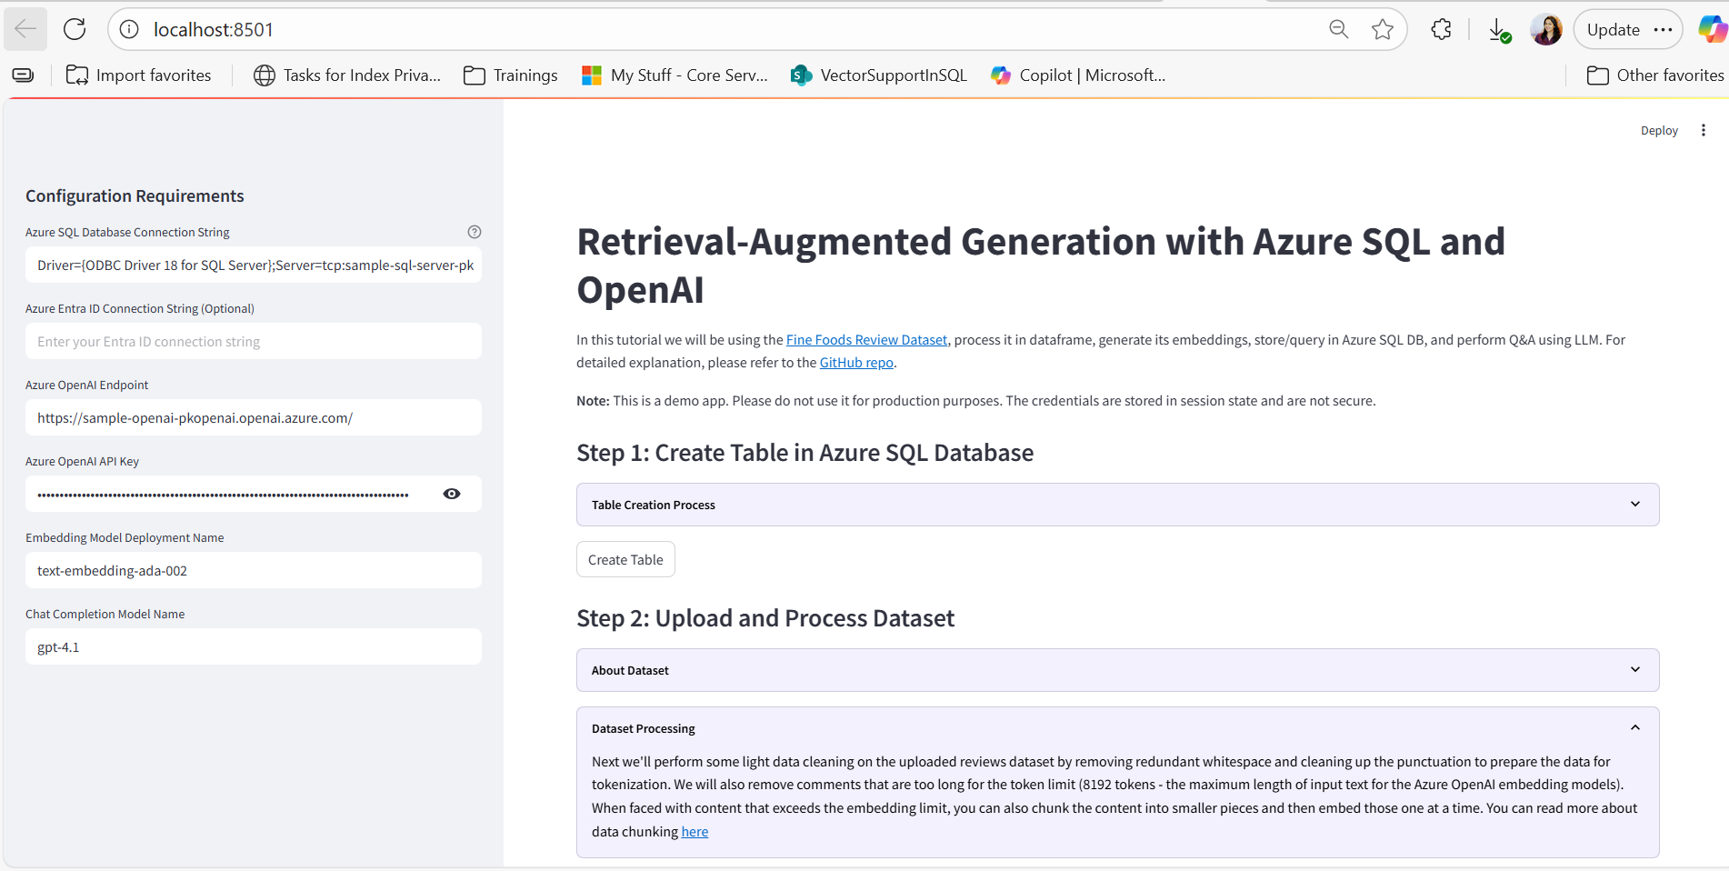
- Add the SQL Connection String , Azure Open AI Endpoint and Key
Ensure you press enter to make sure it is saved.
You can Navigate to the Resource Group in the Azure Portal for the info:
For SQL Connection String:
Navigate to the Database Blade and Click on See Connection Strings
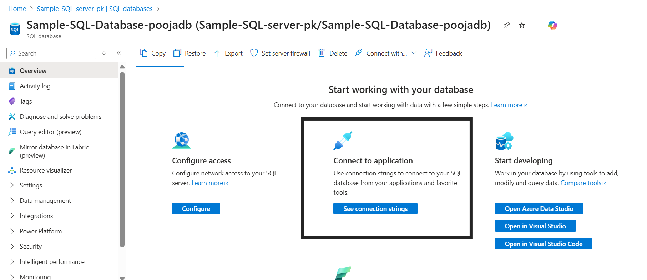
Copy the ODBC Connection String . Ensure you add the Password and paste this in the App.
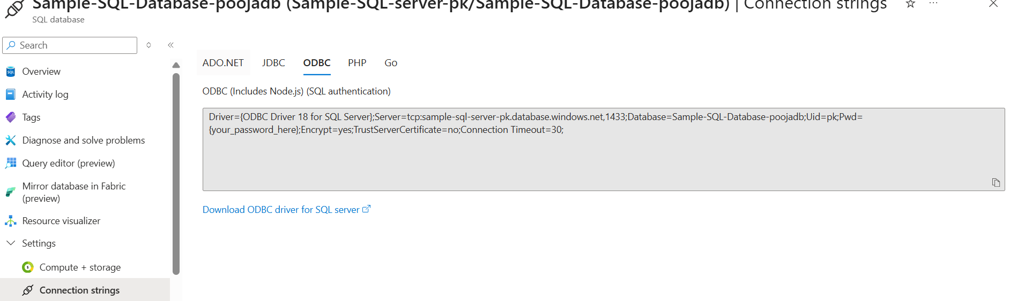
For the Azure Open AI resource – Grab the Endpoint and the Key from the Azure Portal.
Use the Resource Group to Navigate easily
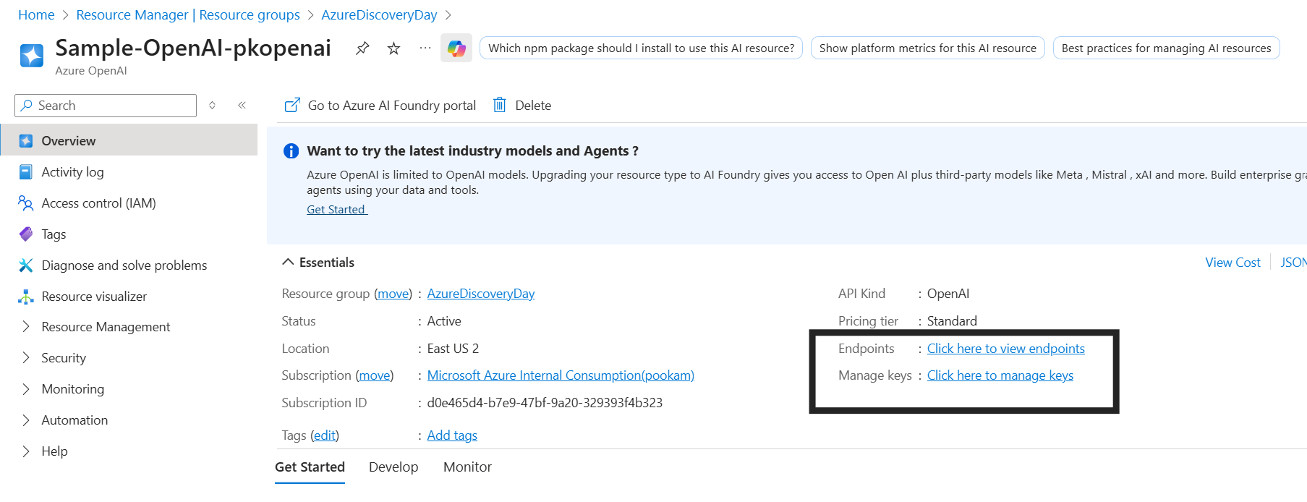
- You can now start using the App:
Start with the Create Table Step by simply clicking the button. You can use the Drop down to see the syntax we are using.
Note: You may see the Table creation fail due to an error like the below: This is due to the Free Serverless Database going into Pause state. Wait a few seconds and run the Create table again . This should now succeed
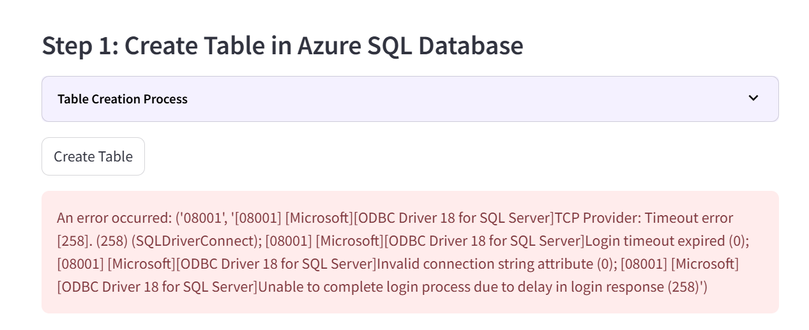
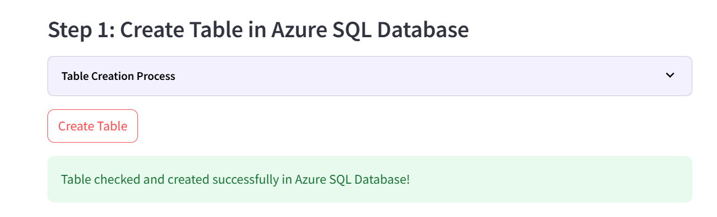
12. Download the Reviews.CSV file that contains Customer reviews for Amazon Fine Food Items and upload it in the App to visualize
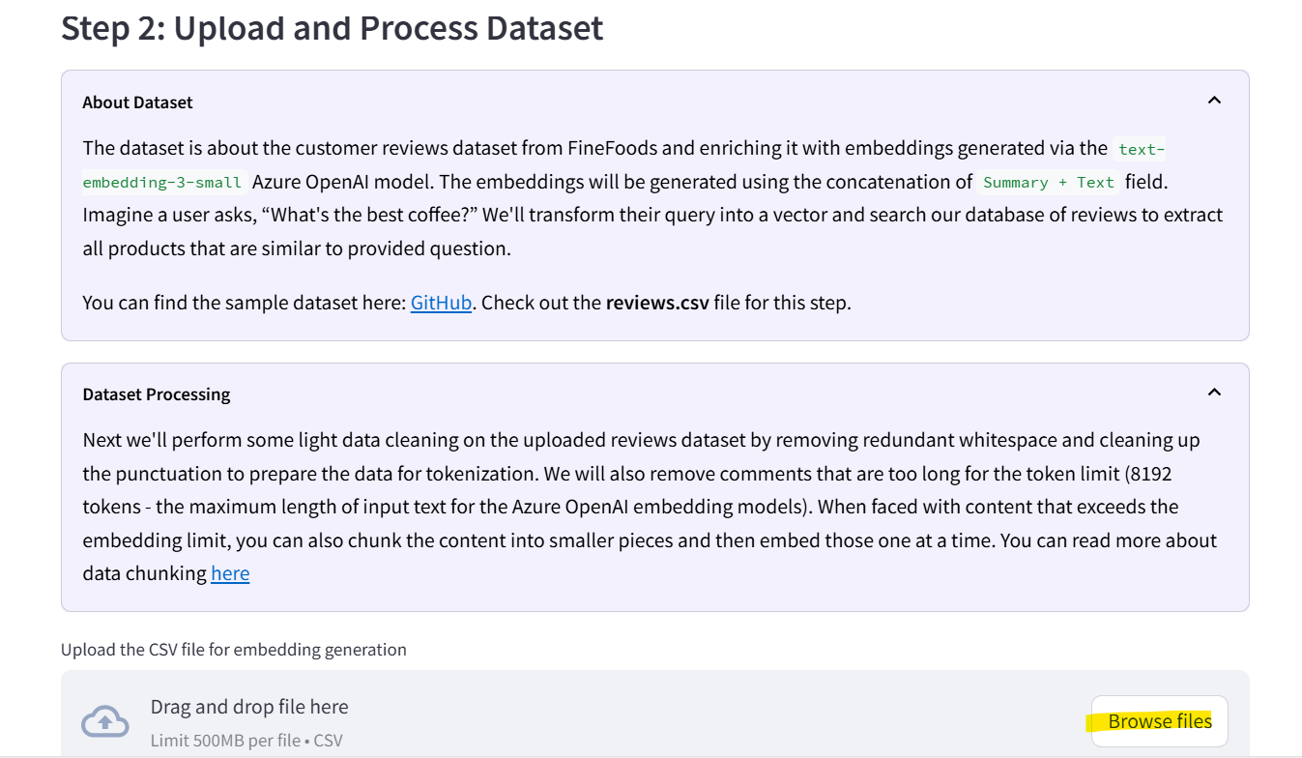
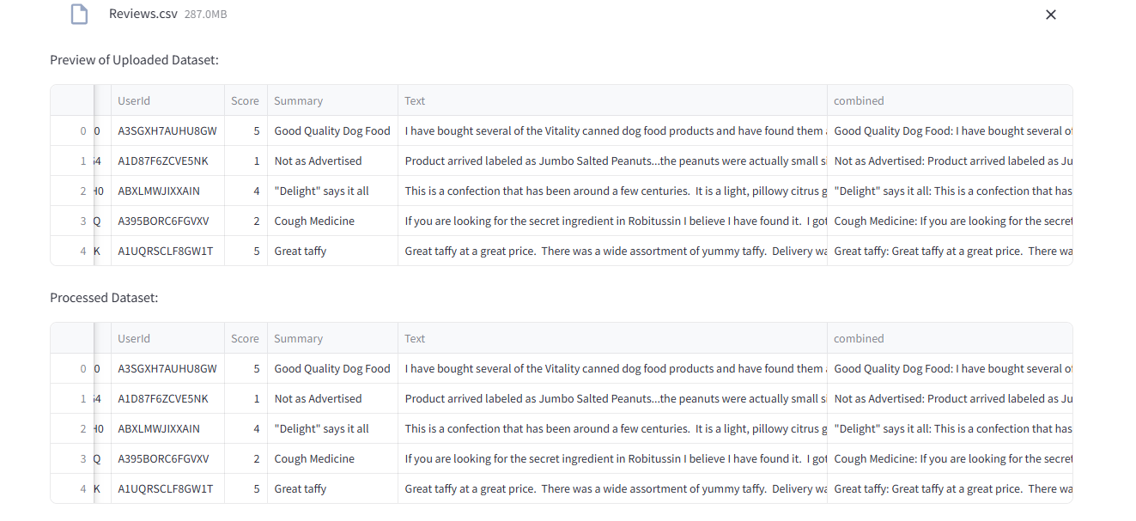
- Next Click on Generate Embeddings to see a demo of how the Embeddings model generates embeddings for the Combined column.
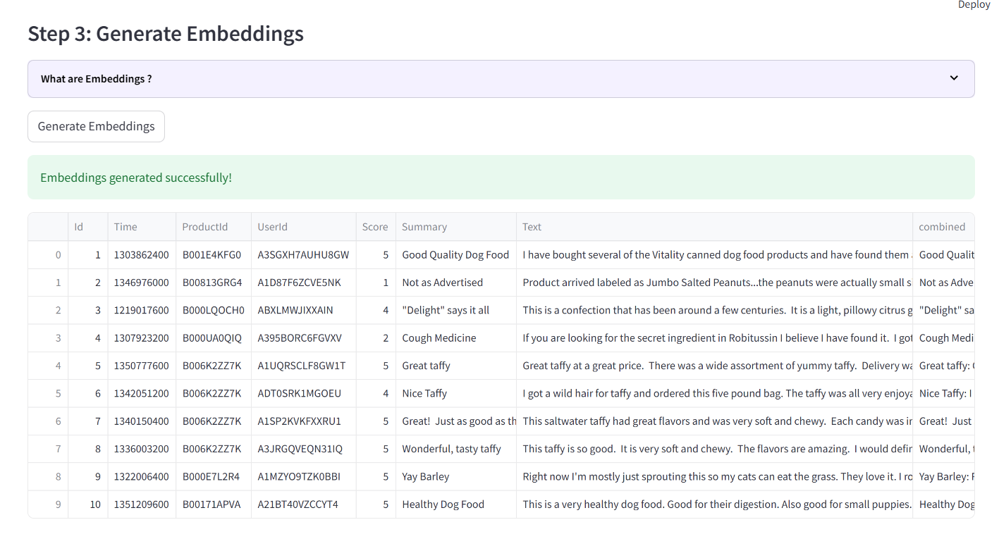
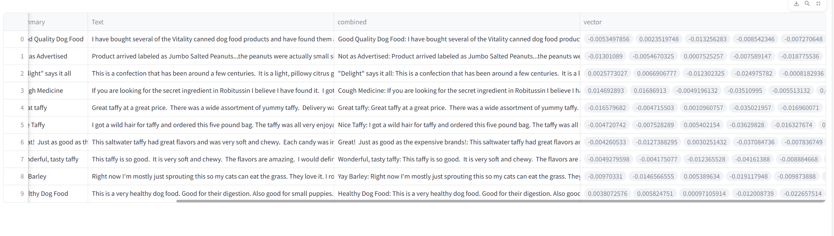14. Since we are using Trial subscription resources for the purpose of the demo we shall use pre- generated embeddings from the .CSV file.
You can download this from the Dataset here:
File Name: finefoodembeddings_textembedding_ada002.csv
After upload comple – Click on Insert Pre-Generated Embeddings into Database.
- This can take a few mins if your Database is in an Azure Region that is far away and is also a Free Tier Database with limited Vcores
- For production or large-scale scenarios, consider using BCP (Bulk Copy Program) or Bulk Insert for faster ingestion.
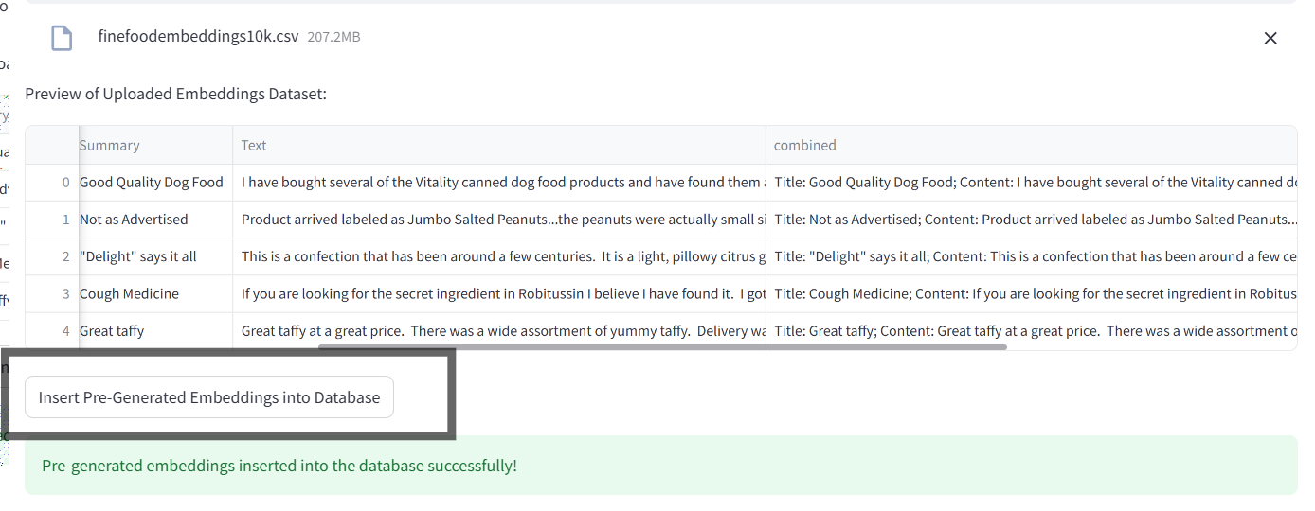
15. Next, we can perform Vector Search using the VECTOR_DISTANCE Function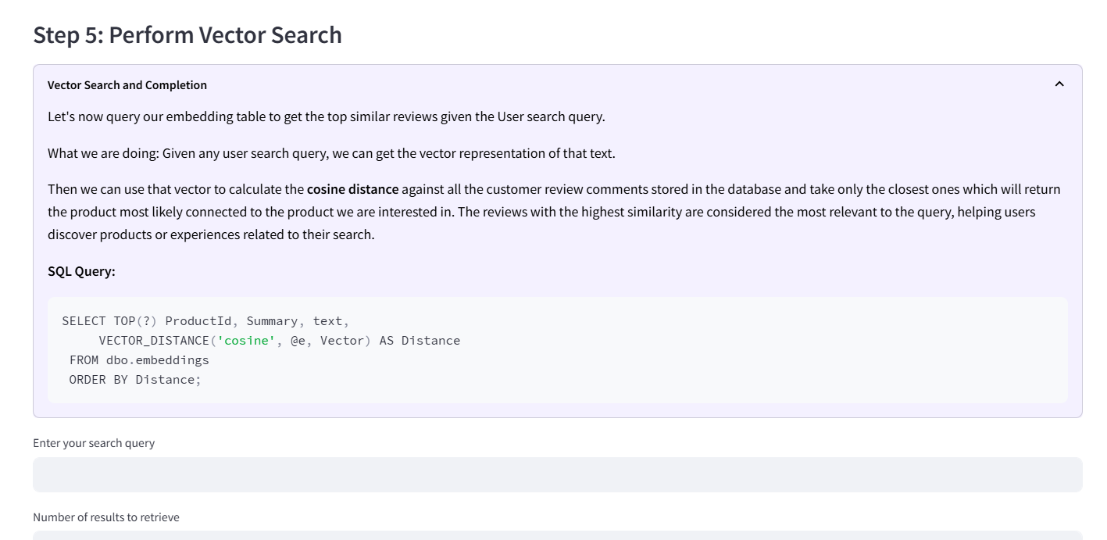
Add a search term like “Organic Baby Food”
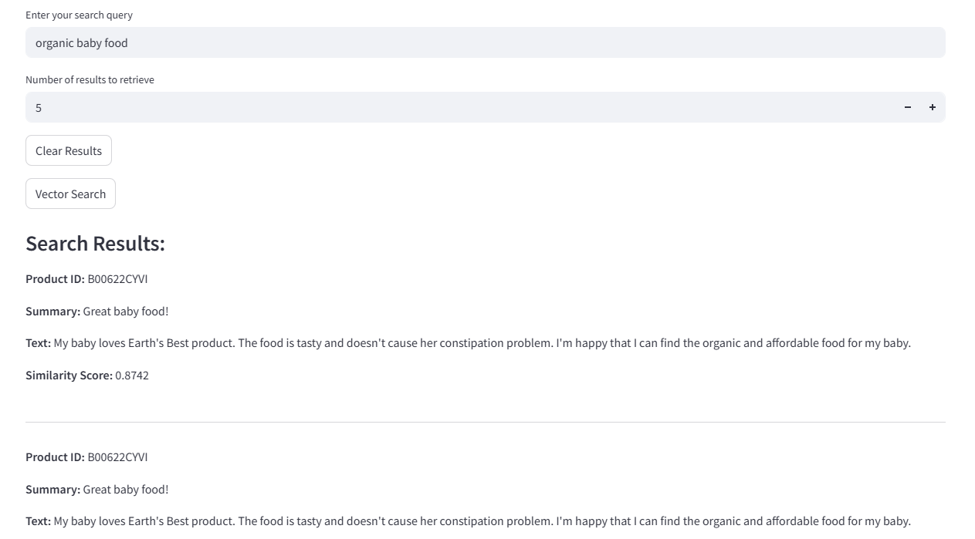
Note: The vector search doesn’t rely on exact keywords. It uses semantic similarity, meaning it understands that terms like “natural” and “organic” are related. This makes the search more intelligent and context-aware compared to traditional keyword search.
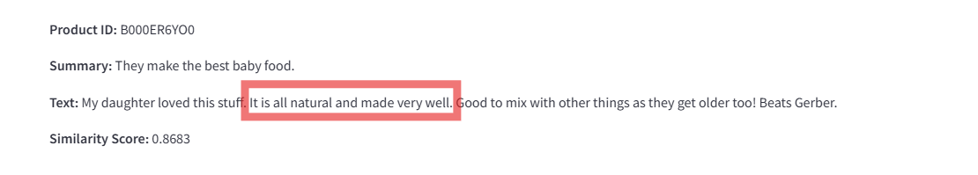
16. Using LLM’s for Chat Completion:
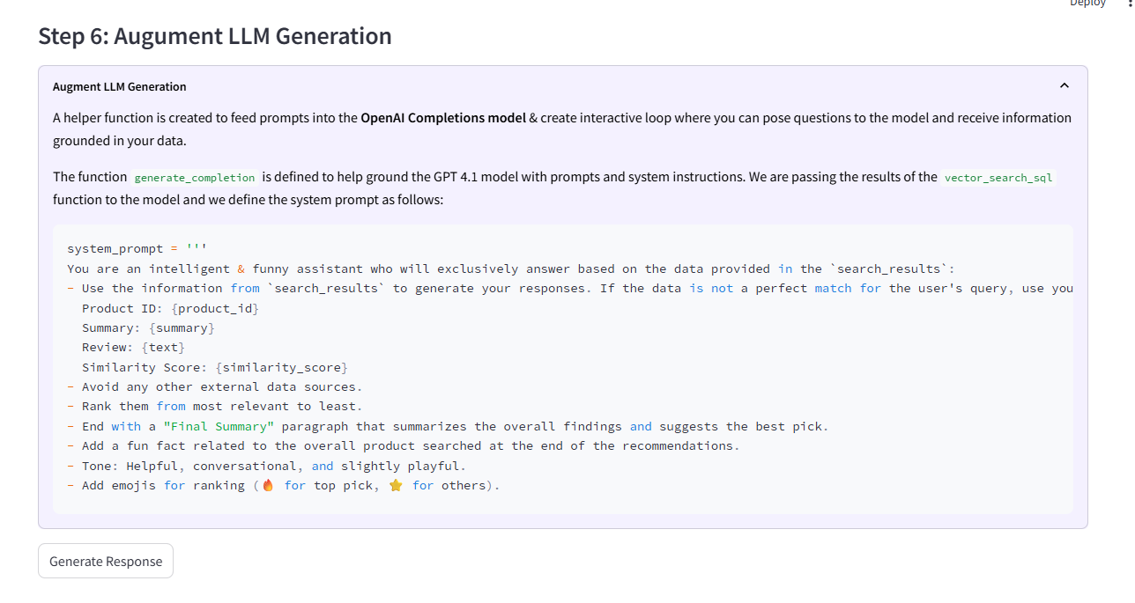
Now that we’ve retrieved the most relevant results using vector similarity (cosine distance), we’ll take it a step further and use LLM generation.
Why add LLM on top of vector search?

  - Vector search gives us the closest matches based on embeddings, but it only returns raw text or structured data.
LLM generation helps:
  - Summarize and present results in a user-friendly format.
  - Answer questions in natural language using the retrieved context.
  - Combine multiple results into a coherent, insightful response.
  - Add creativity (e.g., recommendations, explanations, fun facts).

In short, vector search finds what is relevant, and LLM generation explains why it matters and how to use it
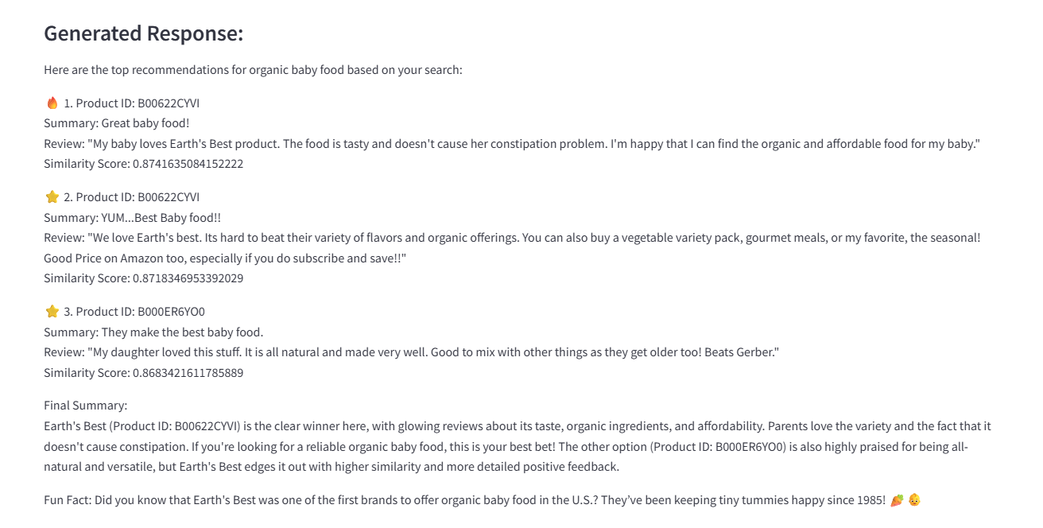

Congratulations! 🎉
You have successfully deployed your SQL AI application. Your app is now capable of performing semantic vector search and leveraging Azure OpenAI for intelligent recommendations. This means you can go beyond keyword matching and deliver context-aware insights directly from your SQL data.

